**Information System Management Lab**

**BCOM 307**

**Assignment #30**

***Submitted by:***

**Name:** YASH JAIN

**Enrollment No:** 03914788818

**Semester:** B.Com(H) 5TH Semester

**Class:** B.COM(H)

**Section:** B.Com 5A

**Date of Submission:** 26/11/2021

***Submitted to:***

**Praveen Kumar Singh**

**Assistant Professor, MAIMS**



**Department of Commerce**

**Maharaja Agrasen Institute of Management Studies**

**Affiliated to Guru Gobind Singh Indraprastha University, Delhi**

**Sector -22, Rohini, Delhi -110086, India; www.maims.ac.in**

Maharaja Agrasen Institute of Management Studies

Affiliated to GGS IP University; Recognized u/s 2(f) of UGC Recognized by Bar Council of India; ISO 9001: 2015

Certified Institution Sector 22, Rohini, Delhi -110086, India; [www.maims.ac.in](http://www.maims.ac.in/)

Department of Commerce

Academic Year: 2020-21

Semester: Vth

# Assignment No. 30

# Unit No:

**Course/Subject Code:** BCOM 307 **Subject Title: Information System Management Lab**

# Issue Date Last Date of Submission:

**Instructions for Students:**

# All Questions are Compulsory.

1. The student should attach proper cover page for each assignment clearly mentioning the Assignment No.
2. Each assignment should be prepared by the student individually with proper explaination and screenshots.
3. A4 size ruled sheets should be used for the assignment.
4. Assignment pages should be serially numbered at the bottom of page.

***During online education mode, upload scanned copy of the complete assignment including cover page latest by due date.***

|  |  |  |
| --- | --- | --- |
| **Question No.** | **Question** | **CO No.** |
| 1 | Draw an E-R diagram for an e-commerce site who sells the product online. | C**CO1, CO2, CO6** |
| 2 | Convert the E-R diagram into tables accordingly. |
| 3 | Make these tables in MySQL. |

**ASSIGNMENT 30 - ER Diagram to Relational Model II**

**Task 1 : Draw an E-R diagram for an e-commerce site who sells the product online.**

We need to create the E-R Model for the case. It would look like the one given below :

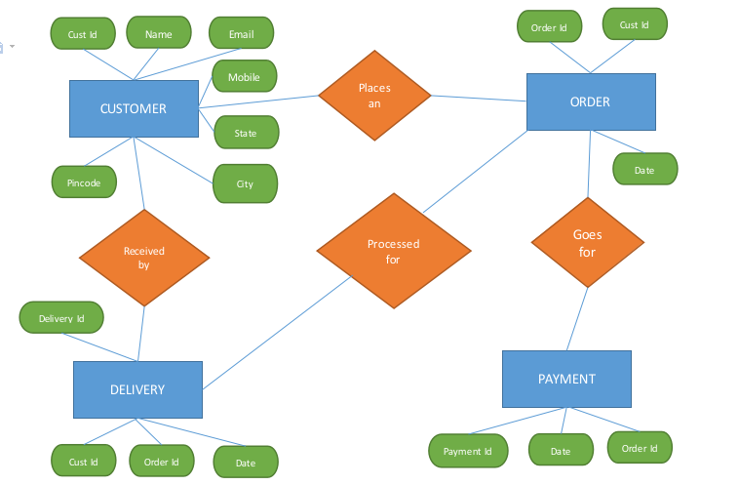

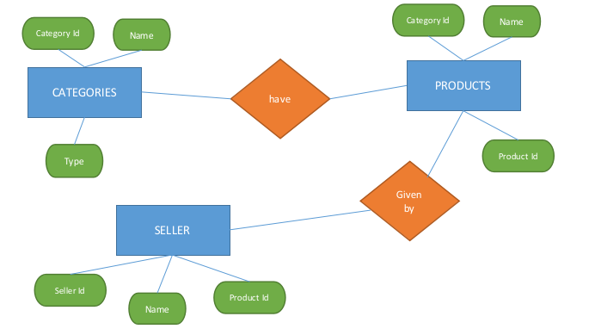

**Task 2 : Convert the E-R diagram into tables accordingly.**

Now, using this ER Diagram, it is time to create the relational model for the case. This is done as given below :

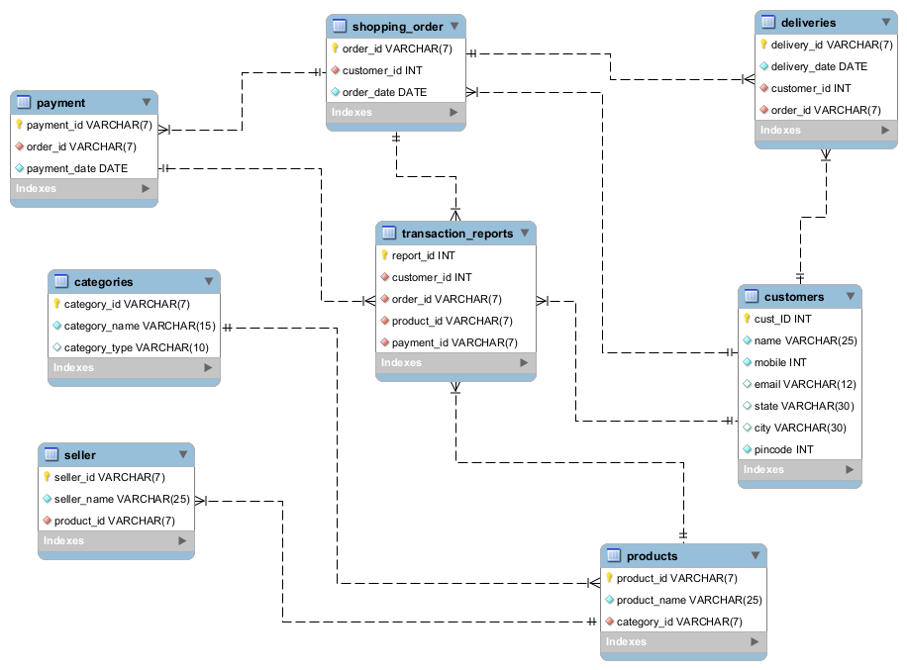

**Task 3 : Create these tables in MySQL.**

This task can be completed using the **CREATE TABLE** Command.

